IT240 Introduction to Databases

HW1
Due Date: See D2L for Deadline
Reading: Bagui & Earp Ch 1. (pp. 1-8), Ch2 (pp. 23-42), Ch. 3 (pp. 53-63) and Ch. 4 (pp. 73-78)

Ch. 1 (pp. 1-8) The software Engineering Process and Relational Databases – stop at “The Relational Model.“
Ch. 2 (pp.23-42) The Basic ER Diagram: A Data Modeling Schema – stop at “ER Design Methodology” (the one with examples, after “More about Attributes” section.
Ch. 3 (pp.53-63) Beyond the First Entity Diagram – stop at “Chapter Summary.”
Ch. 4 (pp.73-78) Extending Relationships/Structural Constraints – stop at “Many-to-Many (M:N).”

Reading using Bagui & Earp 2nd Edition: Ch1. (pp. 1-8), Ch2. (pp. 20-32), Ch4. (pp. 67-80), Ch5. (pp. 101-111), Ch6. (123-128).
Note: There are two parts to this assignment; each part requires you to submit a file. I will give you two submission locations on the course web site.
Part 1:
Your task in this part is to, given an E-R diagram, identify the entities, attributes, keys, and relationships in the E-R model, and generate a corresponding formal written description in the format discussed in class.
Your tasks are:

1. Given the E-R diagram on the following page, list the names of the entities, attributes, keys and relationships being used.

2. For each entity, give a formal written description, including all of its attributes and its key.

3. For each relationship, give a formal written description of both directions of the relationship, including its cardinality.

Submit a single document containing your written answers as your solution to Part 1. Be sure that this document contains your name and “IT240 Part 1_yourlastname.pdf” at the top.

Part 2:

Note: Diagram free Software

You can use many free software as an alternative to MS Visio to create your E-R Diagram I recommend using Draw.io but here is link to all free software:
https://www.maketecheasier.com/5-best-free-alternatives-to-microsoft-visio/

We will be using one of 2 option to create the E-R Diagram:

Option 1: Draw.io
1. Open your Internet Browser and go to Draw.io
2. Click on Create New Diagram

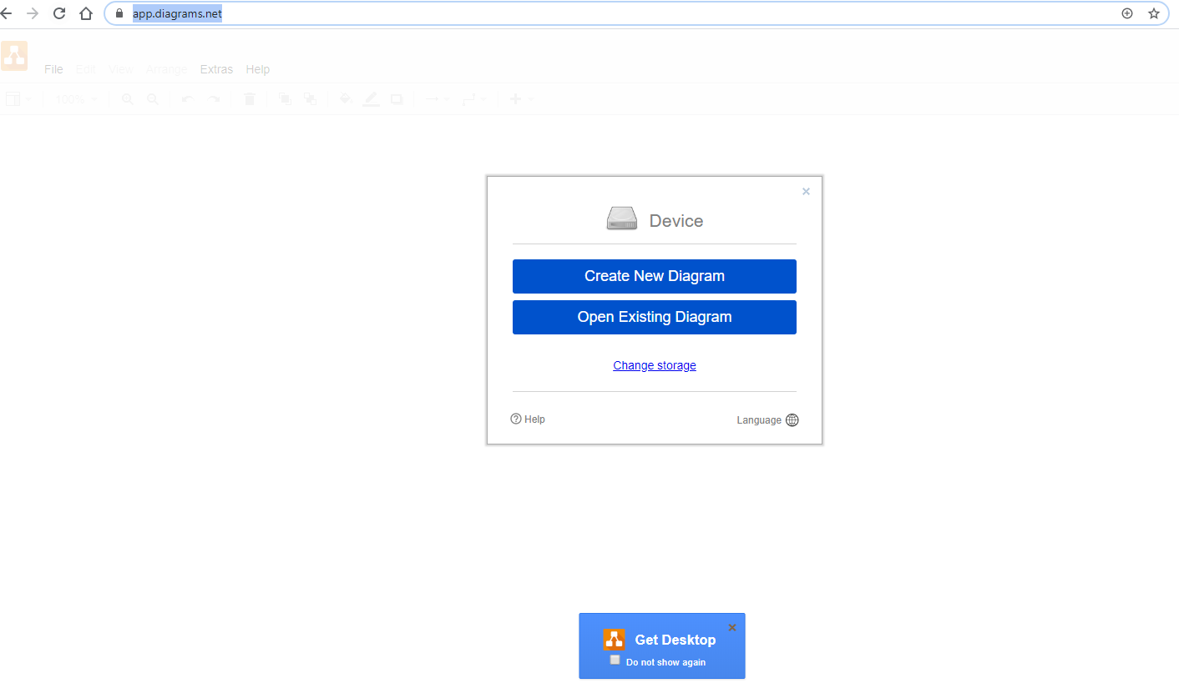

3. Click on Entity Relationship Diagram

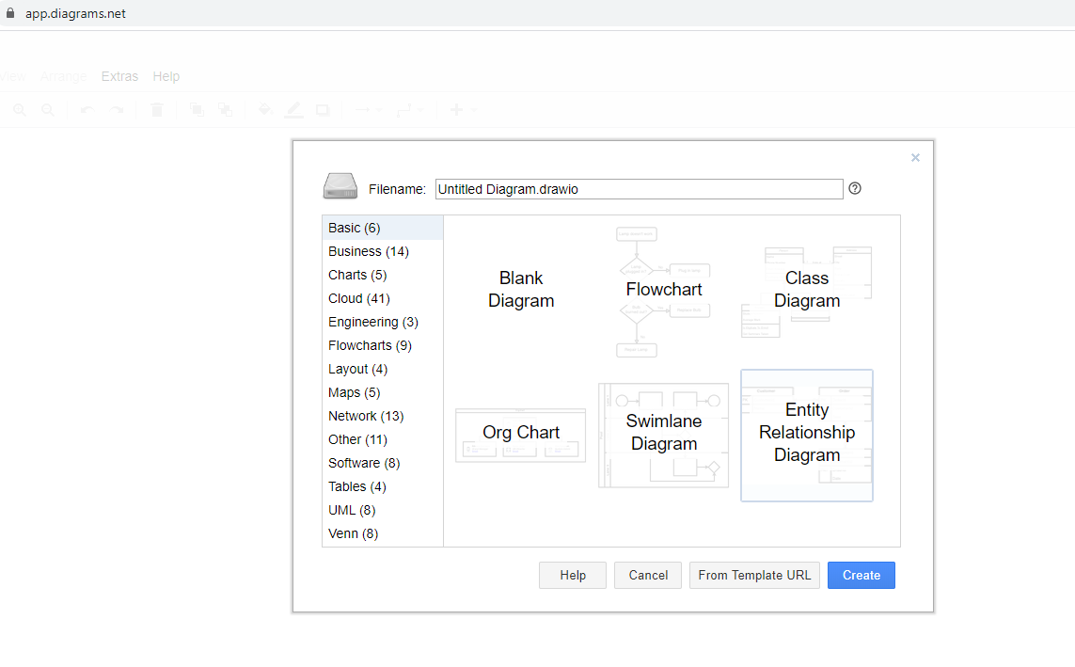
Option 2: Microsoft Visio

Prof. Rami note:
You can access MS Visio Latest Edition using the DePaul Virtual Lab: Azure Virtual Desktop (AVD):

https://depaul.service-now.com/sp?id=kb_article_view&sysparm_article=KB0010985&sys_kb_id=b836a5361b9670108e0e337cdc4bcb56&spa=1

Follow instructions on the link to remotely access Visio.

We will be using Microsoft Visio 2007 to create Entity-Relationship Diagrams. Visio 2007 can be found in the CDM labs, or you can obtain a copy through the MSDNAA link on the CDM web site (http://www.cdm.depaul.edu/Current%20Students/Pages/MSDNAA.aspx).

In this walkthrough, I will take you through the steps of creating a simple E-R Diagram as a Basic Block Diagram in Visio 2007. While Visio 2007 has a variety of specialized templates, all we will need is the basic block diagram and a few shapes (Box, Circle, Diamond, Dynamic connector, Line-curve connector, Text Box). Getting comfortable with this takes a bit of practice and some time spent experimenting, but this walkthrough will help you get started. Follow the steps below and submit your completed E-R Diagram as a .vsd file.

To open a new drawing, choose “New” → “General” → “Block Diagram”. (Don’t use a “Database Model Diagram” – that uses a different diagramming convention than we are using.) You should get something that looks like this.

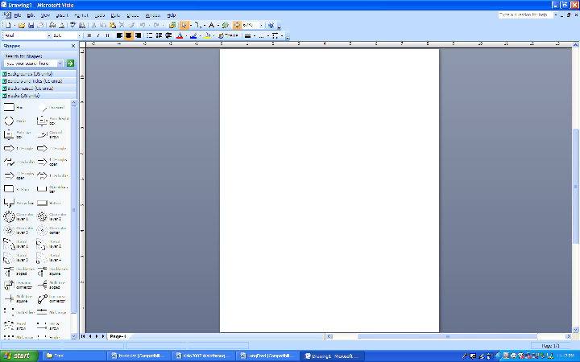

1. Entities: To create a rectangle for an entity, drag and drop a Box into the diagram. You can use the controls around the shape to move and/or resize it as needed. Double-click inside the box to enter and/or edit text – while doing this, you can choose the font, size, underlining, et cetera. (The steps for moving and resizing and adding text are the same for all shapes. You can undo most actions with Ctrl-Z.)

Create two entities, EMPLOYEE and DEPARTMENT. Be sure that the font is large enough to be readable.

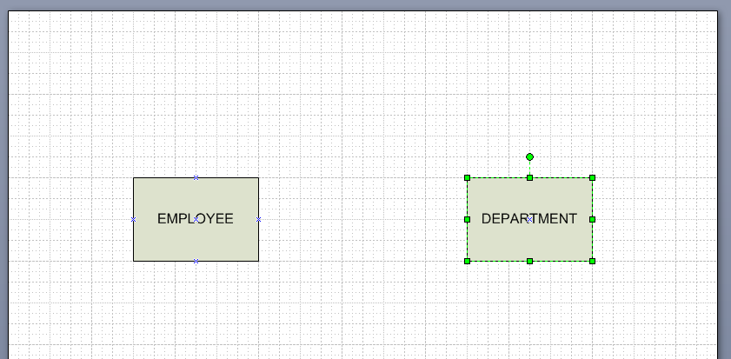

2. Attributes: To create an oval for an attribute, drag and drop a Circle into the diagram, resize it to get an oval, and add the needed text.

To connect an attribute to its entity, drag and drop a Line-curve connector into the diagram. Move its endpoints to the attribute and its entity (they will automatically snap to the edges). Move the center point to make the connector a straight line (there will be a reference point to help you do this), or right-click and choose “Set as Straight Line”.

Add the two attributes EmployeeID and Name and connect them to EMPLOYEE. Add the two attributes Name and HeadCount and connect them to DEPARTMENT. Make EmployeeID the key for EMPLOYEE and Name the key for DEPARTMENT by underlining them.

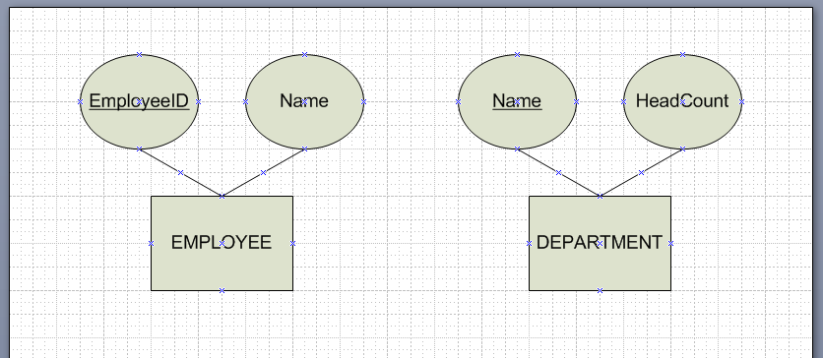

3. Relationships: To create a diamond for a relationship, drag and drop a diamond into the diagram and add the needed text.

To connect the related entities, drag and drop a Line-curve connector into the diagram. Move its endpoints to the related entities (they will automatically snap to the edges). Move the center point to make the connector a straight line (there will be a reference point to help you do this), or right-click and choose “Set as Straight Line”. Add the 1’s and/or M’s along the relationship line by adding text boxes using “Insert” → “Text Box”, typing in the needed values, and setting the font and/or size.

Add the relationship belongs_to between EMPLOYEE and DEPARTMENT. An EMPLOYEE must belong to at most one DEPARTMENT. A DEPARMENT may have many EMPLOYEES belonging to it.

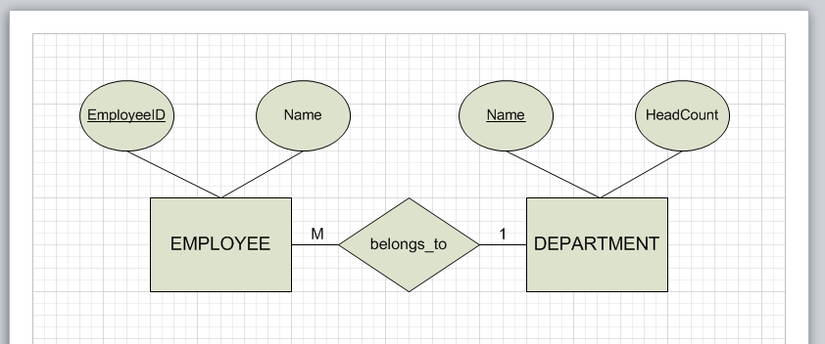

4. Documentation: Finish by adding a text box (as described on the previous page) somewhere in the diagram containing your name and “IT 240 Assignment1”. Save your diagram in the Drawing format – this will create a .vsd file.

Submit this .vsd file as your solution to Part 2.

